IT2020 – Software Engineering
Year 2, Semester 1, 2025
Group Assignment

Online Video Browsing System

Group Details

Campus:

SE/OOP Group Number: SE/OOP/2025/S1/MLB/WD/68

 | Student Registration Number | Student Name
1 | IT23588714 | K H S Dinsara
2 | IT23775442 | T G C Theekshana
3 | IT23584068 | S M M Theekshana Mayadunna
4 | IT23594340 | Shashanka A S

Introduction

Vidoora is an online video browsing platform where users can explore variety of features to get a good movie-watching experience online. If the users visiting the website for the first time, they can create an account by providing necessary information. If users already have accounts, they can login to the site by entering correct credentials. Then users can access their profile page, where they can view and update their personal information. Also, they can view their watch history and track their browsing progress in the profile page.

The videos library of the website has variety of videos to select from different genres, so the users browse through them and select a video they want to watch. Some premium videos require payments to be done. Therefore, our site facilitates making payment through secure payment portal. Users can contact customer service when they have questions, request or complaints regarding the website.

On the other side the system administrators do several things to keep the website active. They manage user accounts and handle payment transactions. They also manage the video library and making sure the videos play properly. The content creator is an essential component of the online video Browsing system since they add new video content to the internet. The Content Creator must log in, select a video, and confirm that it meets the system's standards before posting. Customer service, respond to customer inquiries and manage the blog on the website.

This assignment focuses on designing Vidoora, the online video browsing platform. The project involves creating sequence diagrams and communication diagrams for different use case scenarios, each showing a different part of the site’s functionality. It also includes a complete use case diagram for the whole system. The main goal of this assignment is to visualize the system processes and identify relationships between objects clearly.

The use case scenarios are:
- User profile management
- Video selection and watch
- User make payment
- Add videos

Contents
Introduction 2
Use Case Diagram – Online Video Browsing System 4
Sequence Diagram – User Login 5
IT23588714 – K H S DINSARA 6
Use case scenario – Watch Videos 6
Sequence Diagram – Watch Videos 8
Communication Diagram – Watch Videos 9
IT23584068 – S M M T S MAYADUNNA 10
Use case scenario – Manage User Accounts 10
Sequence Diagram – User Profile Management 12
Communication Diagram – User Profile Management 13
IT23594340 – SHASHANKA A S 14
Use Case Scenario – Make Payment 14
Sequence Diagram – Make Payment 16
Sequence Diagram – View Plan 18
Communication Diagram – View Plan 19
IT23775442 – T G C THEEKSHANA 20
Use Case Scenario – Upload Videos 20
Sequence Diagram – Upload Videos 22
Communication Diagram – Upload Videos 23
Contribution 24

Use Case Diagram – Online Video Browsing System

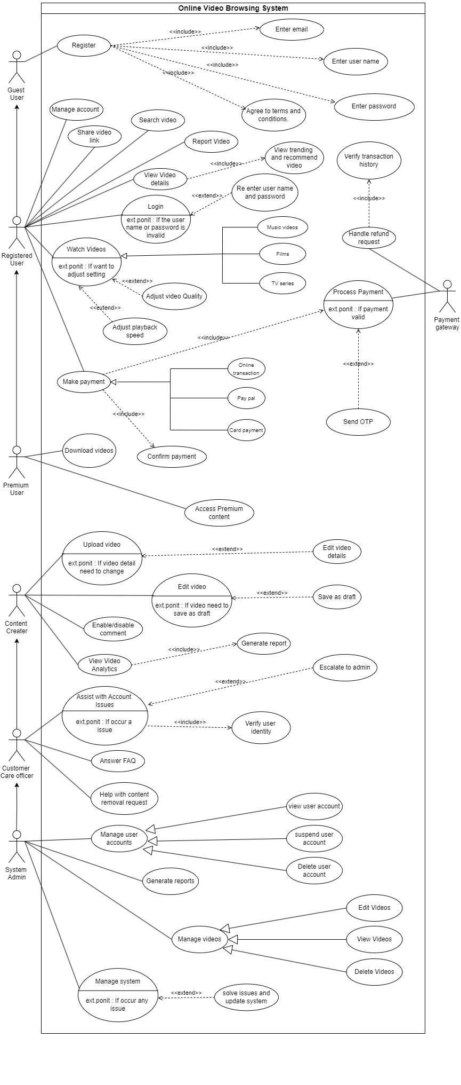

Use case diagram png - Usecase diagram.png

Sequence Diagram – User Login

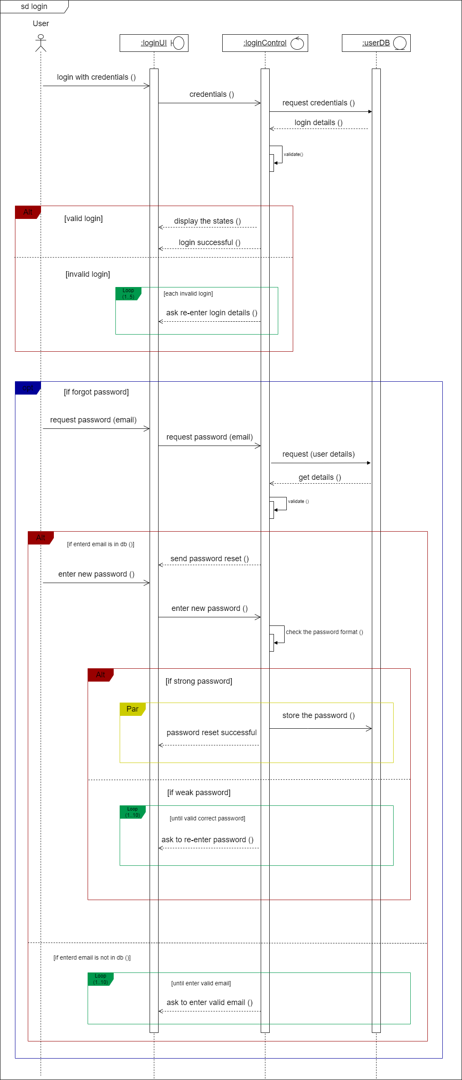

Sequence diagram (User Login) png - login.png

IT23588714 – K H S DINSARA

Use case scenario – Watch Videos
Use case Name | Watch Videos
Summary | The user searches for a video, selects it, and proceeds to watch.
priority | 1
Pre-condition | - User must be a registered user.  - Need to logged into the website with user credentials.
Post-condition | User can search for a video and start watching
Primary actor | Registered User
Trigger | Select “Home Page” option to see all the videos available.
Main scenario | Step | Action
 | (1) | User is redirected to the home page of the website.
 | (2) | User navigates to the “Videos Library” page.
 | (3) | User types a video name or genre in the search bar.
 | (4) | System process the search request by looking through the video database.
 | (5) | System displays the list of videos as the search results.
 | (6) | User clicks on videos to view their descriptions until they find the video they want to watch.
 | (7) | Once the video is found, user clicks on the play button.
 | (8) | System checks the availability of the selected video in the video server.
 | (9) | System checks whether user paid for the video in payment database.
 | (10) | System loads the video using video player.
 | (11) | User presses play button.
 | (12) | User starts playing the video and the user’s input actions (playback speed, quality) sent to the video engine.
 | (13) | Video engine processes user input actions and respond accordingly.
 | (14) | User exits the video.
 | (15) | System checks whether the video progress saved successfully in the user database.
 | (16) | User redirected to home page and logs out from the website.
Extensions | Step | Branching Action
 | (4a) | If no videos match the search criteria
 | (4a-1) | System displays “No results found. Try different keywords.”
 | (8a) | If the video is not available,
 | (8a-1) | The system notifies the user, saying “Video is unavailable. Please try again later.”
 | (10a) | If the video takes too long to load or fails to load
 | (10a-1) | System displays “Video could not be loaded. Check your connection or try again later.”
 | (15a) | If retrieval of video progress unsuccessful or there’s no saved progress,
 | (15a-1) | Video will load with default settings

Sequence Diagram – Watch Videos

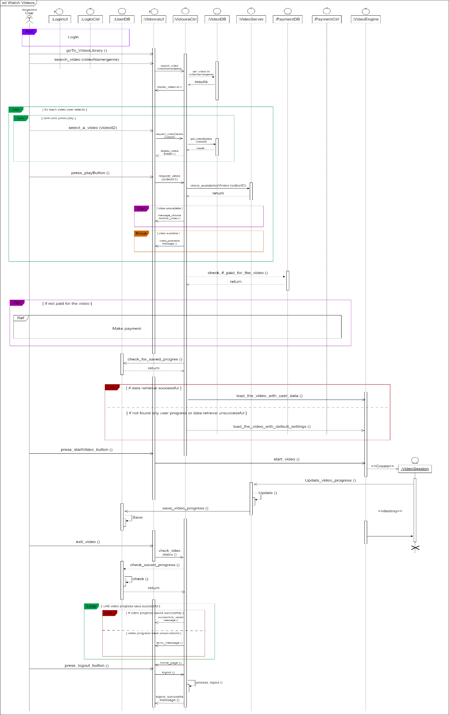

Sequence diagram (Watch Videos) png - watch_videos.png

Communication Diagram – Watch Videos

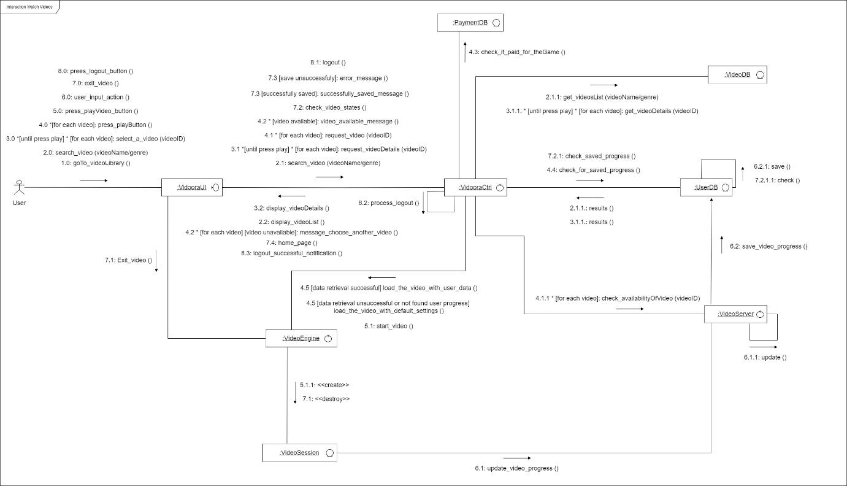

Communication diagram (Watch Videos) - communication.png

IT23584068 – S M M T S MAYADUNNA

Use case scenario – Manage User Accounts

Use case Name | Manage User Accounts
Summary | updated , manage status or deleted user account.
Priority | O1
Pre-condition | The administrator must have an Account to access the admin panel.
Post-condition | The user Account updated , manage account status or deleted based on the admin's action..
Primary actor | System Admin.
Trigger | The Administrator has decided to manage user accounts.
Main scenario | Step | Action
 | (01) | Click login button.
 | (02) | Enter Username and Password.
 | (03) | System verifies admin credentials .
 | (04) | Admin navigates to the User Management UI.
 | (05) | Admin searches for or selects a user profile.
 | (06) | Admin chooses to edit the user profile or manage account status or delete account.
 | (07) | If editing user account, add new details.
 | (08) | System validates the updated data.
 | (09) | Admin submits changes, and the system saves them.
 | (10) | If the admin chooses to manage account status to suspend, active
 | (11) | System performs the requested status action.
 | (12) | If deleting user Account, System check dependency.
 | (13) | System updates dependency and delete user.
Extensions | Step | Branching Action
 | (2.a) | If "Forgot Password" is clicked, prompt to reset password.
 | (2.b) | If entered email is valid, system sends password reset link
 | (2.c) | If reset link received, prompt to enter new password
 | (3.a) | If email is invalid, display "Invalid email" message.
 | (4.a) | If navigation is successful, display User Management UI
 | (4.b) | If navigation fails, display error message.
 | (5.a) | If user does not exist, display "User not found" message.
 | (5.b) | If user does not exist, display "User not found" message.
 | (7.a) | If input format is invalid, display validation error
 | (10.a) | If status change is successful, display "Account status updated" message.
 | (10.b) | If status change fails, display error message.
 | (11.a) | If status is set to "suspended," notify user via email.
 | (11.b) | If status is set to "active," notify user via email.
 | (13.a) | If deletion is confirmed, delete user account and display "User deleted" message.
 | (13.b) | If deletion is cancelled, abort operation and return to user profile.

Sequence Diagram – User Profile Management

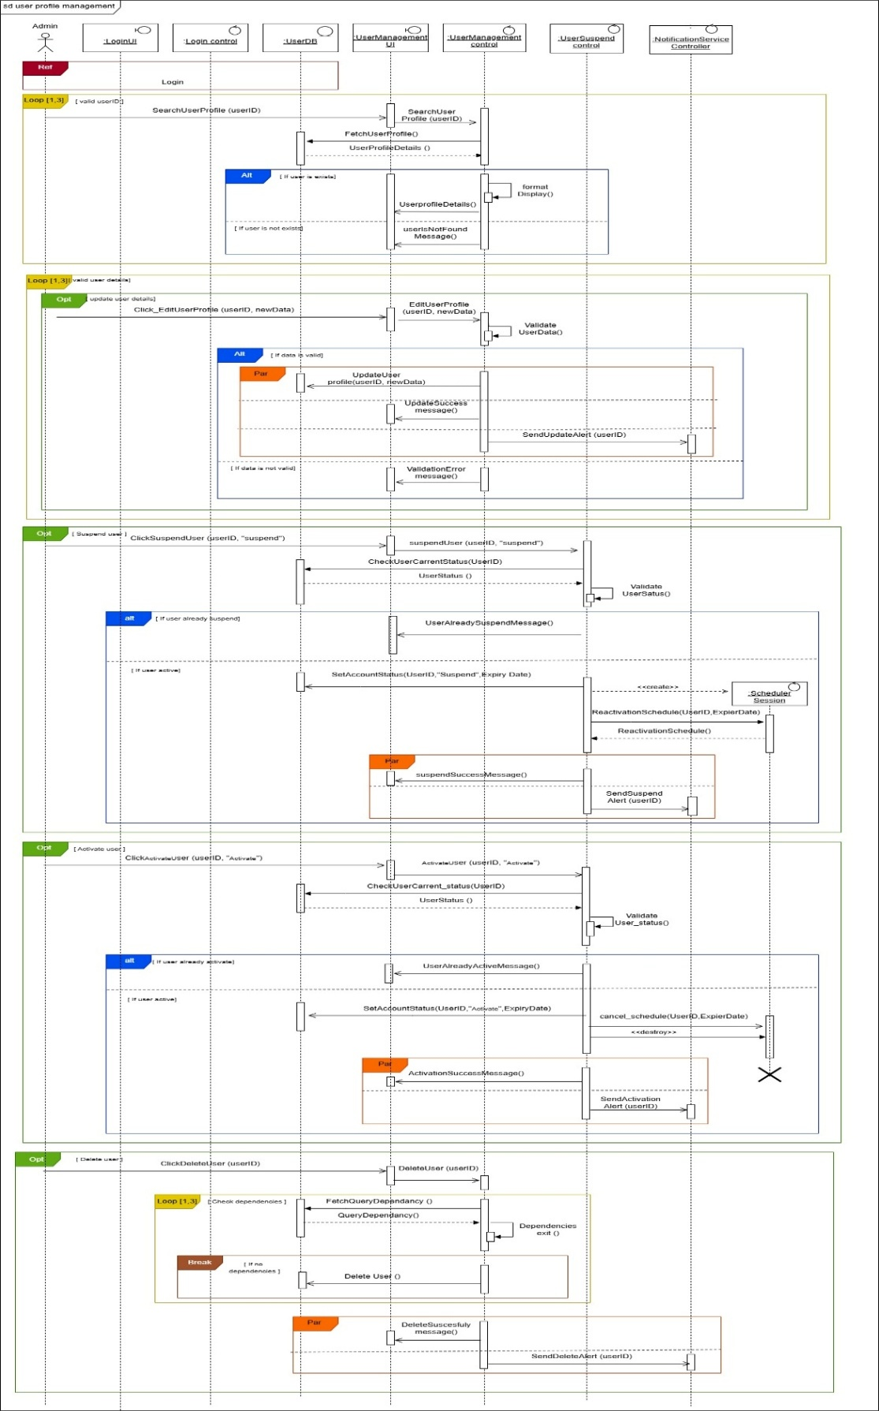

Sequence diagram (User Profile Management) png - seqenceUserManagment.jpg

Communication Diagram – User Profile Management

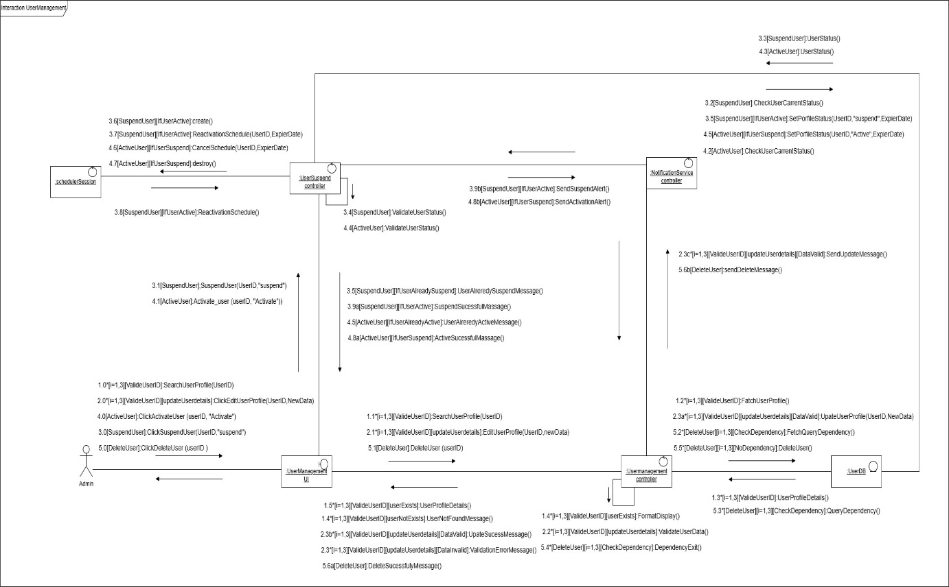

Communication diagram (User Profile Management) - communicationDiagramUserManagment.jpg

IT23594340 – SHASHANKA A S

Use Case Scenario – Make Payment

Use case Name | Make a Payment
Summary | Pay for premium plan
Priority | 5
Pre-condition | Must Login to the system as register user
Post-condition | Payment completed
Primary actor | Register User
Trigger | User has chosen view plan Button
Main scenario | Step | Action
 | (01) | User logs into the system as a registered user.
 | (02) | User clicks on the "View Plan" button.
 | (03) | System displays available premium plans.
 | (04) | User selects a plan.
 | (05)
  The system checks the selected plan price and displays it to the user.
 | (06) | User chooses a payment method (Card Payment or Online Transfer).
 | (07) | For Card Payment: User enters card details.
 | (08)
  System validates entered card details.
 | (09) | If OTP is reserved, the system displays OTP input field.
 | (10)
  User enters OTP code.
 | (11)
  System verifies OTP code.
 | (12) | If verification is successful, system submits payment details.
 | (13)
  System saves the payment record in the database.
 | (14) | System updates the user record in the database.
 | (15)
  System confirms successful payment to the user.
 | (16)
  For Online Transfer: User enters bank account details.
 | (17)
  System validates entered bank details.
 | (18)
  If OTP is reserved, system displays OTP input field.
 | (19)
  User enters OTPcode.
 | (20)
  System verifies OTP code.
 | (21)
  If verification is successful, system submits payment details.
 | (22)
  System saves the payment record in the database.
 | (23)
  System updates the user record in the database.
 | (24) | System confirms successful payment to the user.
Extensions | Step | Branching Action
 | (04) | If the user does not select a plan, the system waits until the user selects one.
 | (05) | If price retrieval fails, system displays an error message to the user.
 | (06) | If the user selects Online Transfer, the system shows the bank details form instead of card form.
 | (08) | If card details are invalid, the system prompts the user to re-enter card details.
 | (09) | If OTP is not reserved, system directly proceeds to submit card details.
 | (11) | If OTP verification fails, system displays an error and prompts user to re-enter OTP.
 | (12)
  If submission fails, system displays an error and allows user to retry.
 | (17) | If bank details are invalid, the system prompts the user to re-enter bank details.
 | (18) | If OTP is not reserved, system directly proceeds to submit bank details.
 | (20)
  If OTP verification fails, system displays an error and prompts user to re-enter OTP.
 | (21) | If submission fails, system displays an error and allows user to retry.

Sequence Diagram – Make Payment
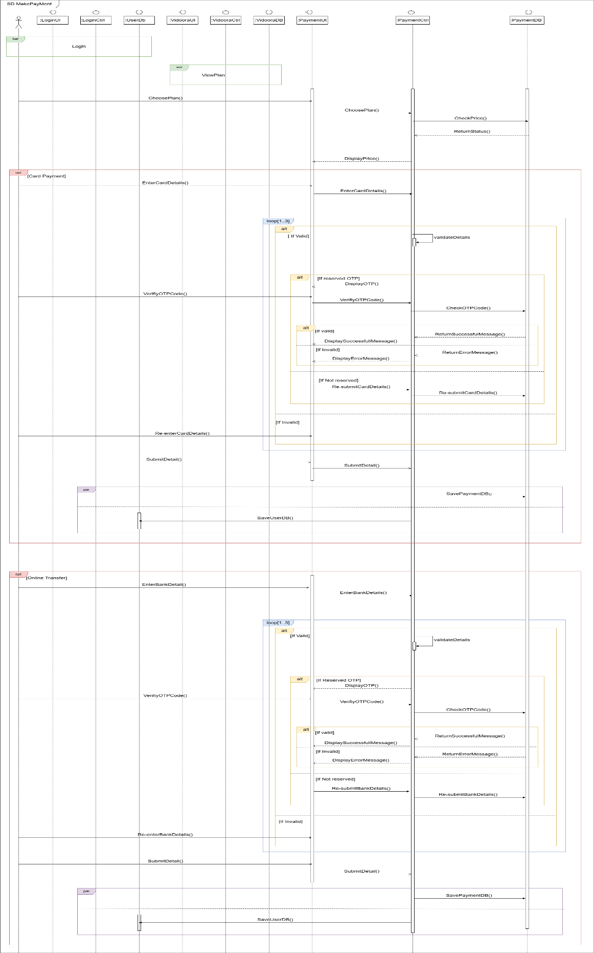

Sequence diagram (Make Payment) png - SequenceDiagram_MakePaymen.png
Communication Diagram – Make Payment

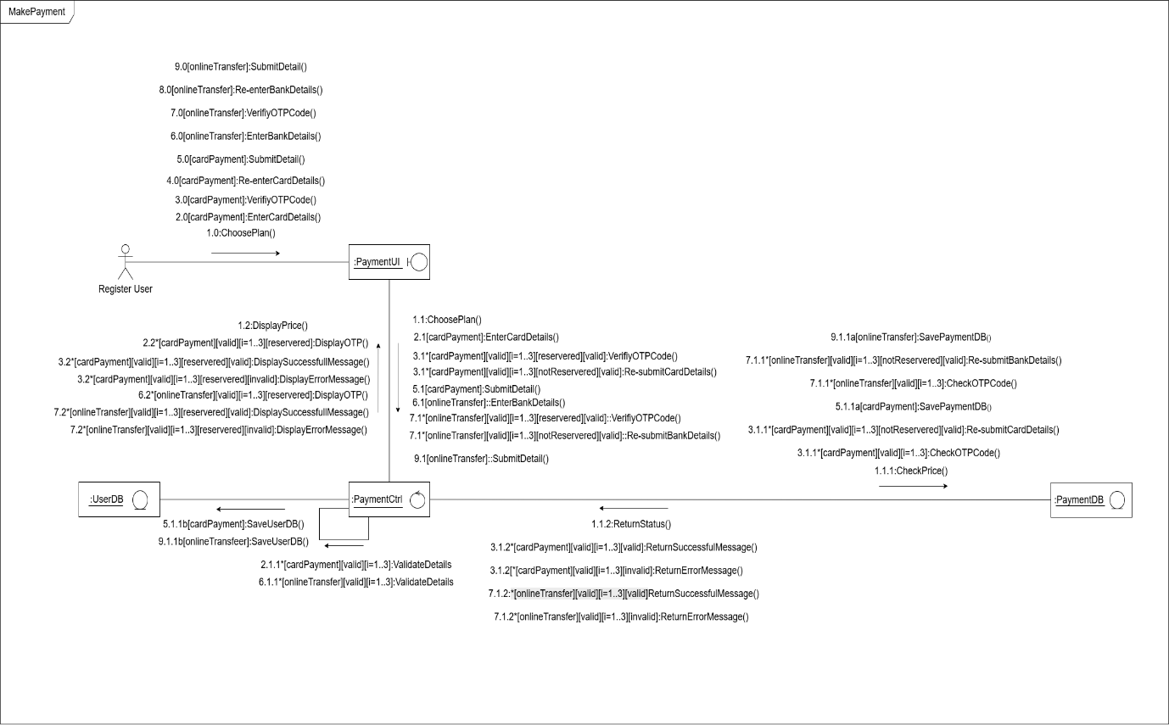

Communication diagram (Make Payment) - CommunicationDiagram_MakePayment.png

Sequence Diagram – View Plan

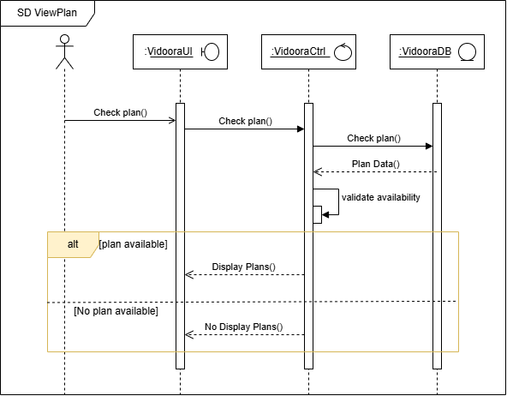

Sequence diagram (View Plan) png - SequenceDiagram_ViewPlan.png

Communication Diagram – View Plan

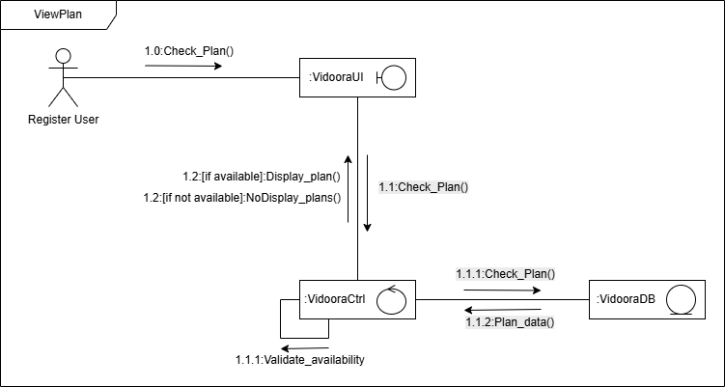

Communication diagram (View Plan) - CommunicationDiagram_ViewPlan.png

IT23775442 – T G C THEEKSHANA

Use Case Scenario – Upload Videos

Use case Name | Upload Video
Summary | Allows a logged-in Content creator to the system and uploads videos.
Priority | 03
Pre-condition | Content creator must be logged into the system.
Post-condition | Video is successfully uploaded and available in the system, or Content creator is notified if the upload fails.
Primary actor | Content Creator
Trigger | Selects the "Upload Video" option from the interface.
Main scenario | Step | Action
 | (01) | Content Creator navigates to the Upload Video page.
 | (02) | The system displays the upload form.
 | (03) | Content Creator selects a video file to upload.
 | (04) | The system validates the file type (must be a supported video format).
 | (05) | The system checks the file size (must not exceed the allowed limit).
 | (06) | System checks the filename for invalid characters or spaces.
 | (07) | Content Creator optionally enters video metadata (title, description, tags).
 | (08) | Content Creator clicks the "Upload" button.
 | (09) | The system starts uploading videos and displays a progress bar.
 | (10) | Content Creator can cancel the upload at any time.
 | (11) | System saves the video to the server if upload completes successfully.
 | (12) | System confirms upload success and displays a success message.
 | (13) | System updates the Content creator’s video list to include the new upload.
Extensions | Step | Branching Action
 | (04a) | If file type is not supported, the system displays an error and prompts the Content creator to select a valid video file.
 | (05a) | If the file is too large, the system displays an error and prompts the Content creator to select a smaller file.
 | (06a) | If filenames contain invalid characters or spaces, the system notifies Content creator and requests a valid filename.
 | (09a) | If the internet connection is lost during upload, the system pauses upload and notifies Content creator resumes when connection returns.
 | (10a) | If user cancels the upload, the system aborts upload and deletes any temporary data; Content Creator is notified.
 | (11a) | If server error occurs during upload, system displays an error message and suggests retrying.
 | (12a) | If upload fails for any reason, system displays a failure message and logs the error for support.

Sequence Diagram – Upload Videos

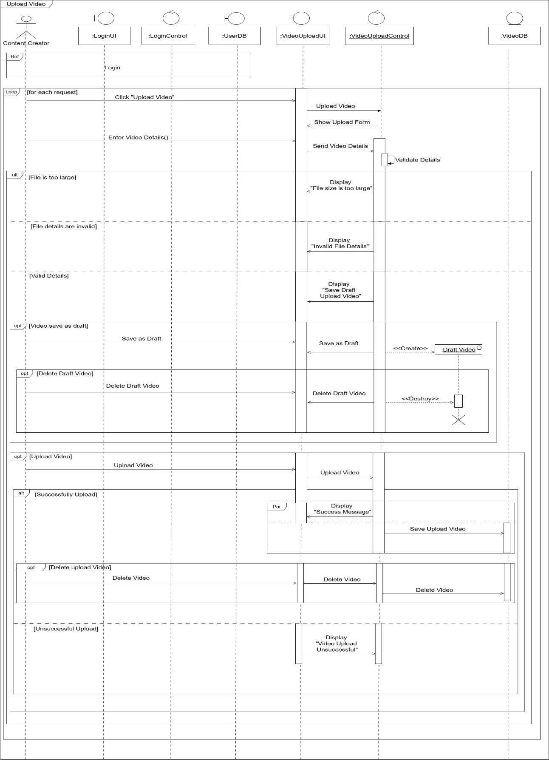

Sequence diagram (Upload Videos) png - (Final)Sequence Diagram.jpg

Communication Diagram – Upload Videos

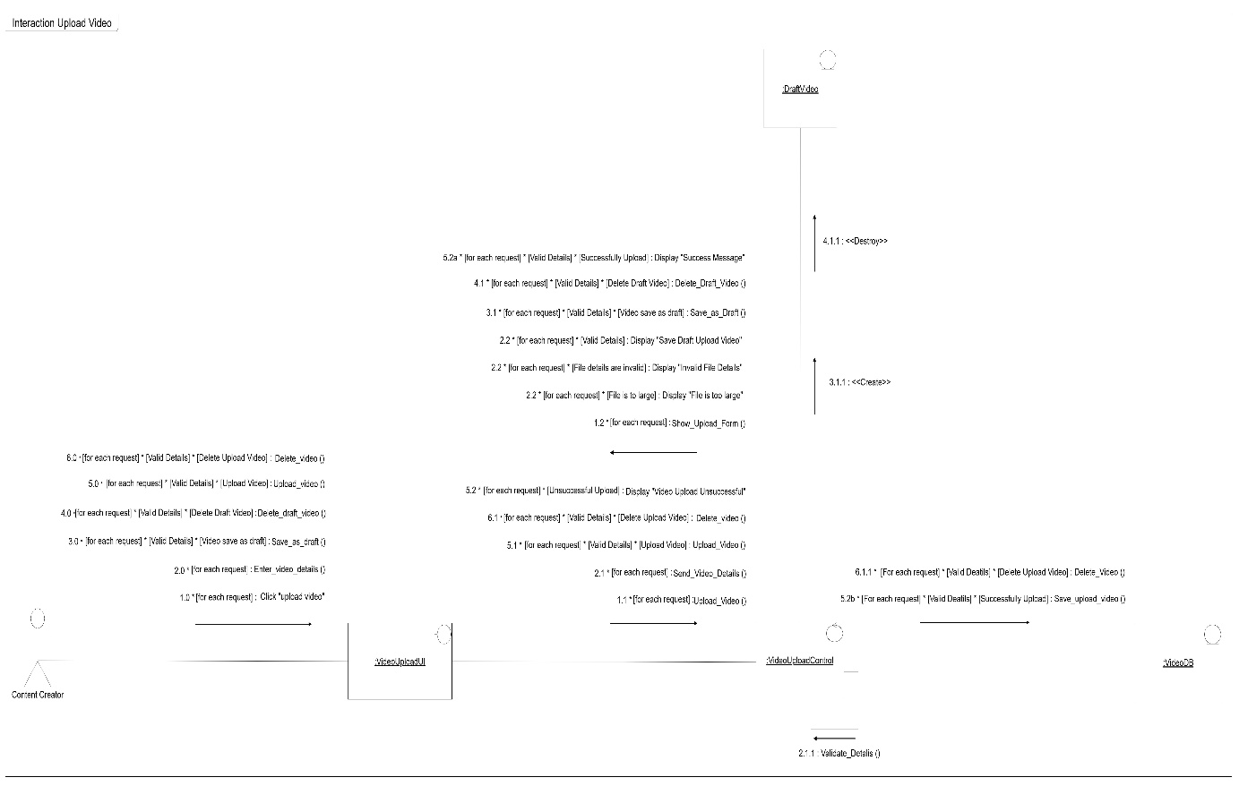

Communication diagram (Upload Videos) - 1 Communication Diagram.jpg

Contribution

Reg. No | Name | Function Name
IT23588714 | K H S Dinsara | Watch Videos
IT23584068 | S M M T S Mayadunna | User Profile Management
IT23594340 | Shashanka A S | Make Payment, View Plan
IT23775442 | T G C Theekshana | Add Videos

